

Cong Xuan Pham

Highlights
- Graduated from Industrial University of Ho Chi Minh City with Computer Science subject.
- Graduated from University of Economics Ho Chi Minh City with Economic Planning and Investment subject
- Develop web application using Java platform fluently
- Have knowledge with Liferay open-source
- Have knowledge with technical leader
- Have knowledge with deploying e-Government software
- Can work with high pressure
- Goals: become a good leader, manage team to build a project with best result and have good remarks from customer.

Employment History (list in order latest first)

Developer  April 2013 – Present | Orient Software Development Corporation  5th floor, Suite 5.8, e.town 1 building, 364 Cong Hoa Str, Ward 13, Tan Binh Dist, Ho Chi Minh City, Vietnam  Direct line +84 8 3812 0101  URL www.orientsoftware.net
Technical leader  August 2012 – March 2013 | FTP IS SOFT  3rd floor, CMC Plaza, 79B, Ly Thuong Kiet Str, Ward 8, Tan Binh Dist, Ho Chi Minh City, Vietnam  Direct line  URL http://www.fis.com.vn
Technical leader  September 2007 – July 2012 | TRUONG SON SOFT Co, Ltd  769/5, Cach Mang Thang Tam Str, Ward 6, Tan Binh Dist, Ho Chi Minh City, Vietnam  Direct line  URL

Responsibilities and Contribution

Education
Time | School or Course
2000-2004 | Industrial College No.4
2005-2007 | Industrial University of Ho Chi Minh City
2009-2011 | University of Economics Ho Chi Minh City

Summary of Skills
Application Development | Proficiency Level
 | Level | Years | Last Used
JAVA core | Advanced | 7 | 2014
JSP, Servlet | Advanced | 6 | 2014
HTML/CSS/JavaScript/Jquery | Advanced | 7 | 2014
XML | Advanced | 6 | 2014
Liferay open-source portal | Advanced | 7 | 2014
Lucene | Advanced | 4 | 2014
ExtJS | Intermediate | 1 | 2014
BIRT reports | Intermediate | 1 | 2014
jBPM | Advanced | 3 | 2013
JSF | Intermediate | 0.5 | 2013
ICEfaces | Intermediate | 0.5 | 2013
Velocity | Intermediate | 1 | 2013
Spring/Hibernate | Intermediate | 2 | 2012
RTF reports | Advanced | 4 | 2013
DWR/AJAX | Advanced | 2 | 2013
Coldfusion | Advanced | 3 | 2008
C# | Intermediate | 2 | 2008
PHP | Intermediate | 0.5 | 2004
ASP/ASP.net | Intermediate | 0.5 | 2004
C/C++ | Intermediate | 1 | 2004
Database Application Development | Proficiency Level
MySQL | Advanced | 7 | 2014
PostgreSQL | Advanced | 6 | 2013
SQL Server | Advanced | 4 | 2011
Oracle 9i | Intermediate | 0.5 | 2009
Developing Tools and Technology | Proficiency Level
Eclipse | Advanced | 7 | 2014
Apache Ant | Advanced | 7 | 2014
GIT | Intermediate | 1 | 2014
Visual SourceSafe | Advanced | 6 | 2013
SVN | Advanced | 2 | 2012
SQL server studio 2008 | Advanced | 3 | 2011
Dreamweaver | Advanced | 3 | 2008
Visual studio 2005 | Intermediate | 2 | 2007
Others Knowledge | Proficiency Level
SCRUM | Intermediate | 1 | 2014
LINUX | Intermediate | 0.5 | 2014
Tomcat | Advanced | 7 | 2014
JBoss | Intermediate | 0.5 | 2013
Coldfusion server | Advanced | 3 | 2008

Outstanding Projects

Project Name | Message Stream Project (MSP) | Duration
Position(s) | Developer | 1 year
General information | - MSP is a project from Australia. It’s controlled by Digital Alchemy Company. The home page is http://www.digitalalchemy.com.au  - The project helps user to send a lot of emails automatically. It provides a lot of reports and charts for user to view the status of mail.
Description | - The project uses services from third-party to create/modify/send email automatically. The third-party company is Exacttarget at http://www.exacttarget.com  - The project can do:  - Control email details: image, content, template, personalization ...  - Send email manually and automatically  - Provide a lot of reports about email status  - Provide a lot of chart to view the trend of sending email  - Our customers have another system to generate data file. We use the data file to send email to many recipients. We can send email to one million customers at the same time. After that, user uses the project to get reports/charts to view the result of sending email.
Interface systems | - 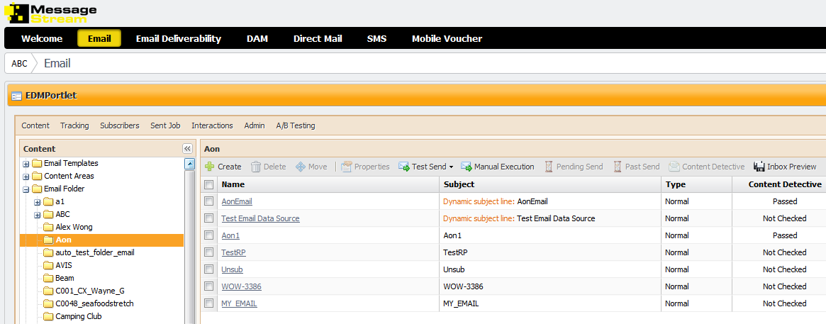
Technology used | - Liferay open source portal  - ExtJS  - GIT  - MySQL  - Java core  - Hibernate  - JSP  - AJAX  - BIRT reports

Project Name | Handbook of remarkable IT  products and services of HCM City | Duration
Position(s) | Technical leader  Developer | 8 months
General information | - Customer: Department of Information and Communications of HCMC  - Build portal Handbook of remarkable IT products & services of Ho Chi Minh City  - Introduce software companies.
Description | - Our customer want to have portal to:  - Introduce remarkable IT products and services  - Introduce IT companies  - Support users to vote good products and services  - Is a gate to communicate between IT company and customer  - Support IT companies  - Use Open-source portal to build portal.
Interface systems | - 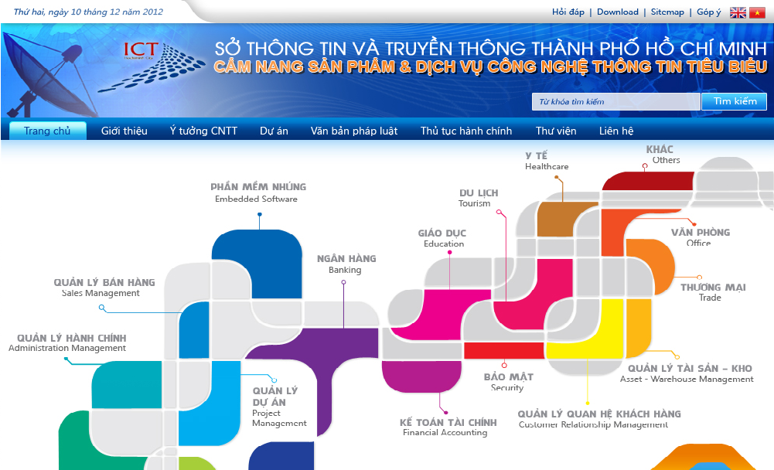
Technology used | - Liferay open-source portal  - JSP  - CSS  - Javascript  - AJAX  - Velocity  - RTF template  - PostgreSQL  - Sourcesafe

Project Name | ICT of HCMC Management | Duration
Position(s) | Technical leader  Developer | 1 year
General information | - Customer: Department of Information and Communications of HCMC  - Management e-records
Description | - Build a portal that manages records. It controls about 25 record types and licenses  - Integrate information with one gate system of HCMC.  - Provide reports about record processing.  - Combine with ICTI of HCM City to develop and deploy.  - Convert old software to new software.
Interface systems | - 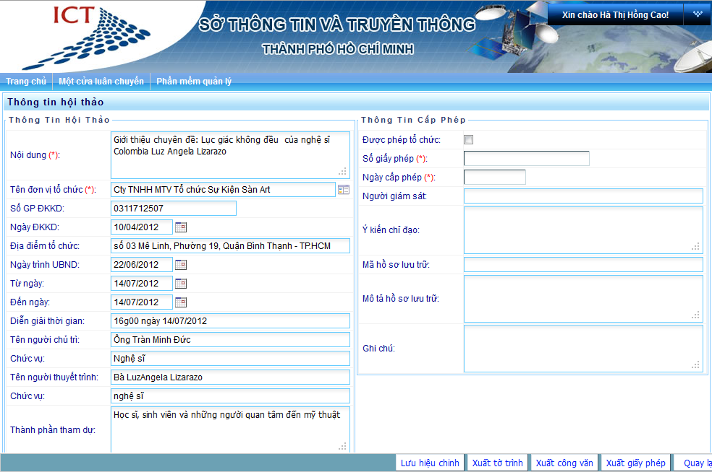
Technology used | - Liferay open-source portal  - JSP  - CSS  - Javascript  - AJAX  - Velocity  - RTF template  - PostgreSQL  - SVN

Project Name | Department of Industry Commerce Management | Duration
Position(s) | Technical leader  Developer | 1 year
General information | - Customer: Department of Industry Commerce of HCMC  - Management e-records and e-documents
Description | - Build a portal that manages records and documents.  - Provide report about record and document processing  - Convert old software to new software.  - Integrate data from Excel to PostgreSQL.
Interface systems | - 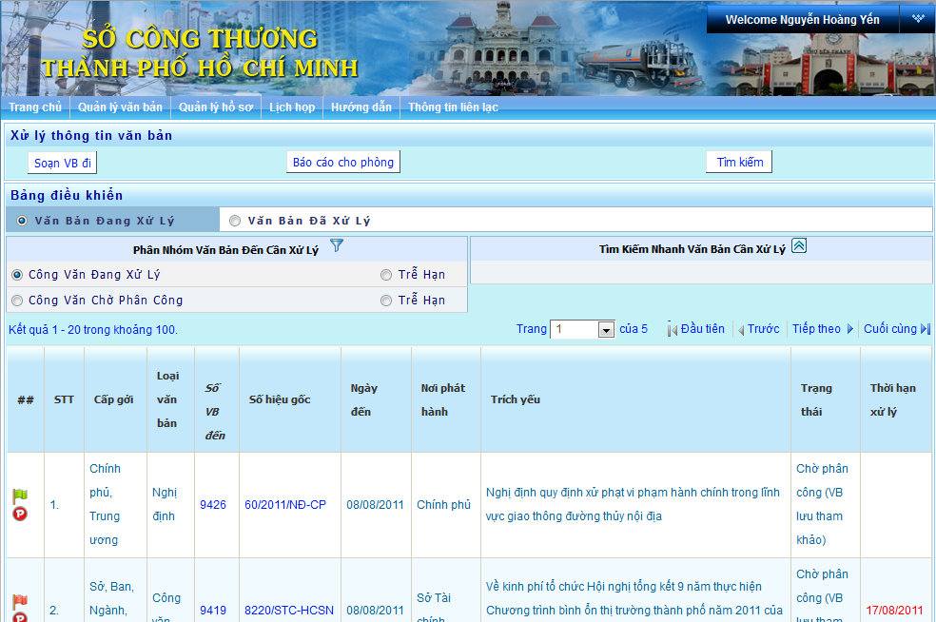
Technology used | - Liferay open-source portal  - JSP  - CSS  - Javascript + DWR  - AJAX  - Velocity  - RTF template  - PostgreSQL  - SVN



